|  |
| --- |
| **FoodBox**  **(Application Screenshot)** |

**Version History:**

|  |  |
| --- | --- |
| Author | Mayur Bharatkumar Solanki |
| Purpose | Screenshot of the application |
| Date | 4th March 2022 |
| Version | 1.0 |

Contents

1. Homepage 4

2. Registration Page 5

3. Login Page 6

6

4 Add to Cart 7

5 Search Result 8

6 Previous OrderList 9

7 Cart 10

8 Checkout 11

9 Confirmation Page 12

12

10 Database 13

1. Homepage

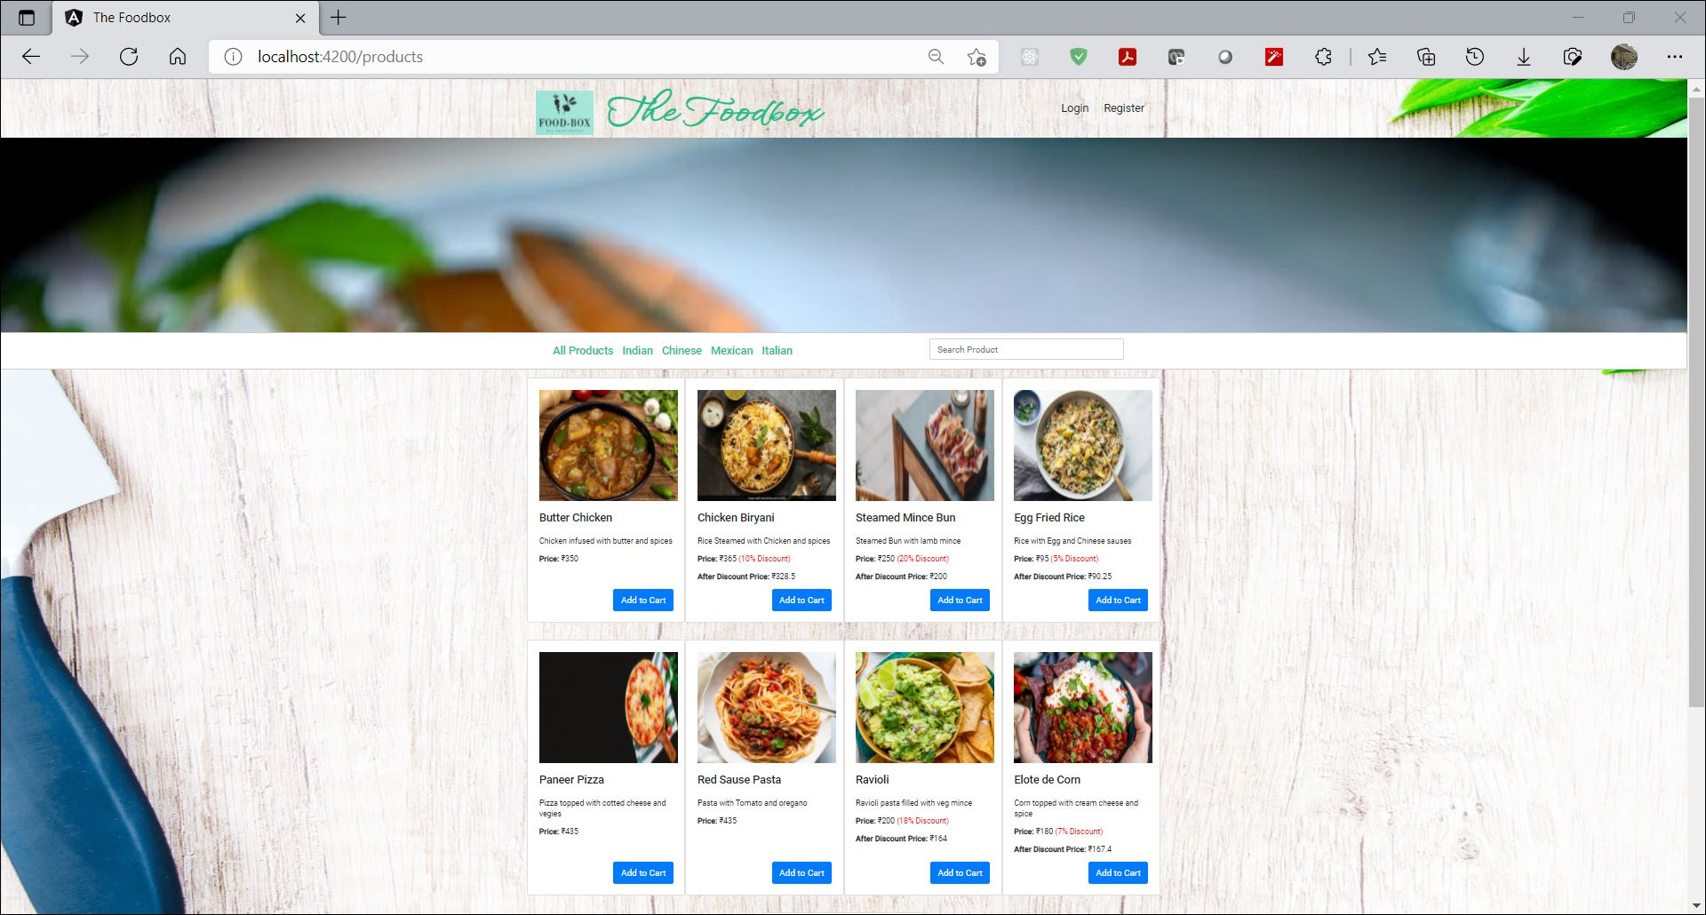

1. Registration Page

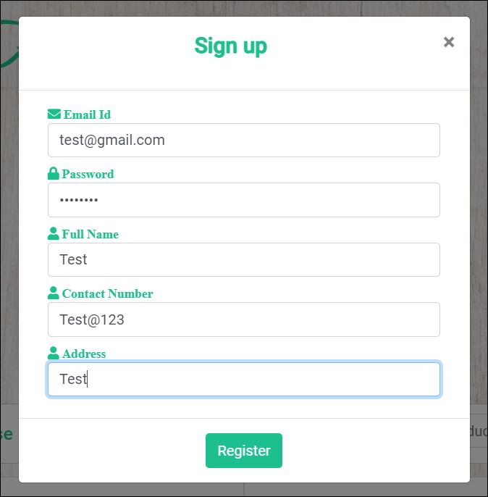

1. Login Page

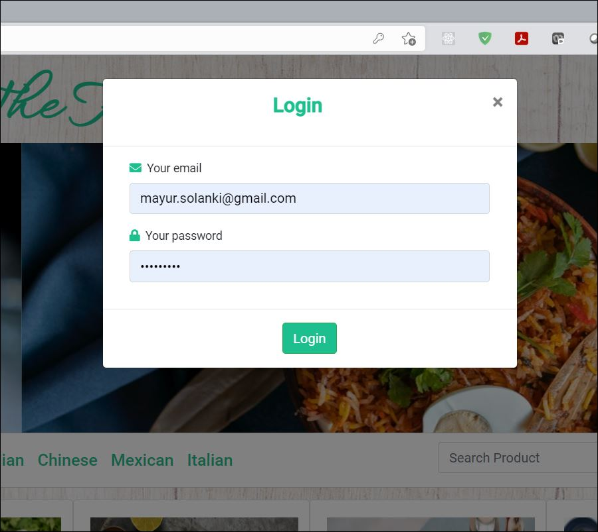

1. Add to Cart

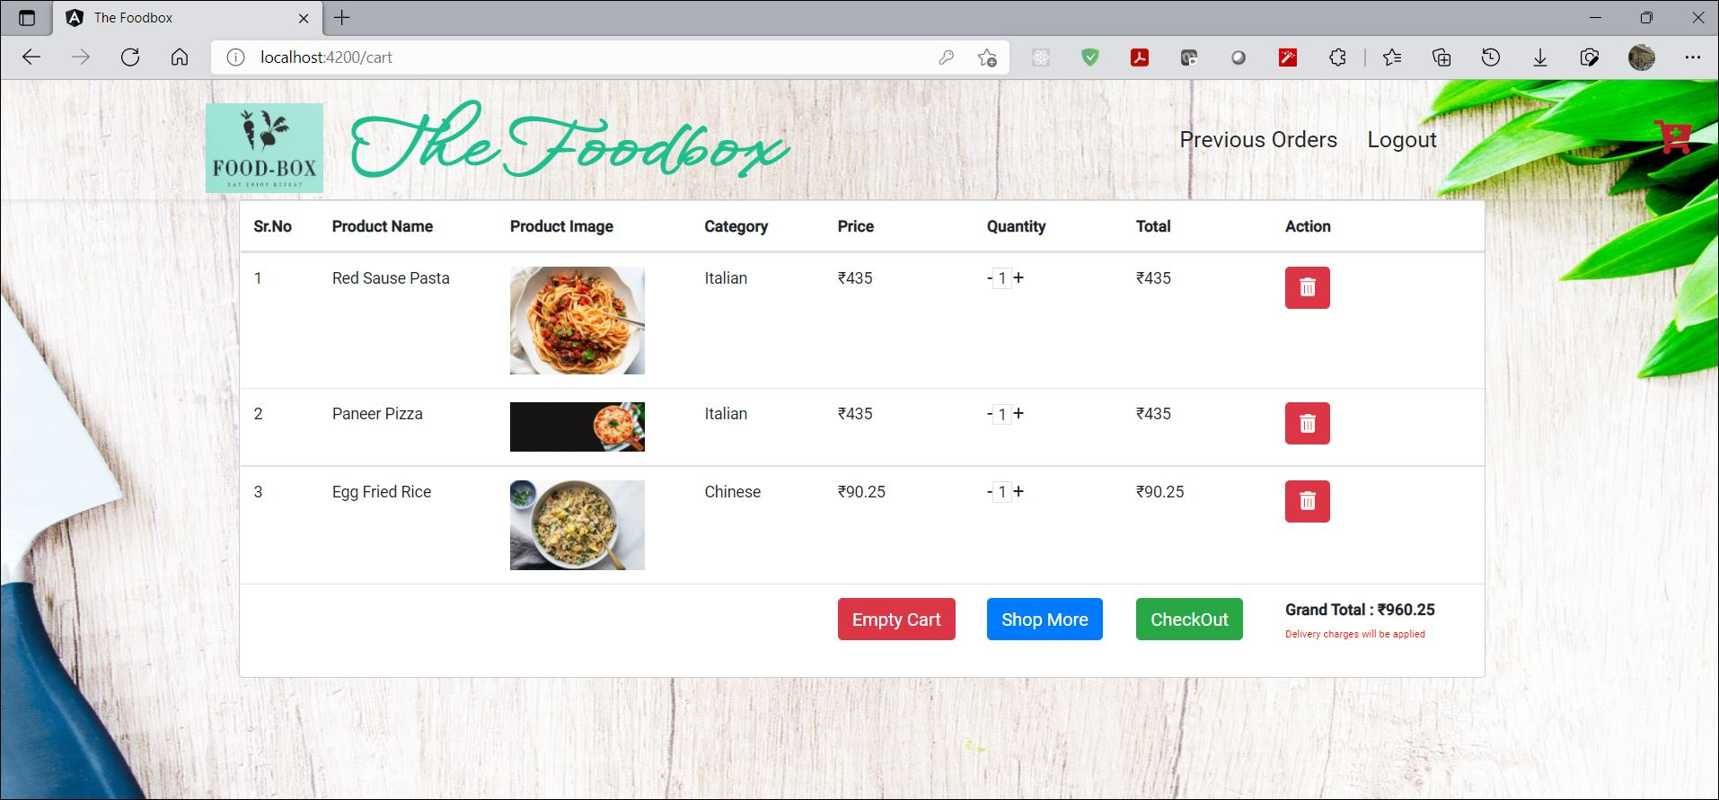

1. Search Result

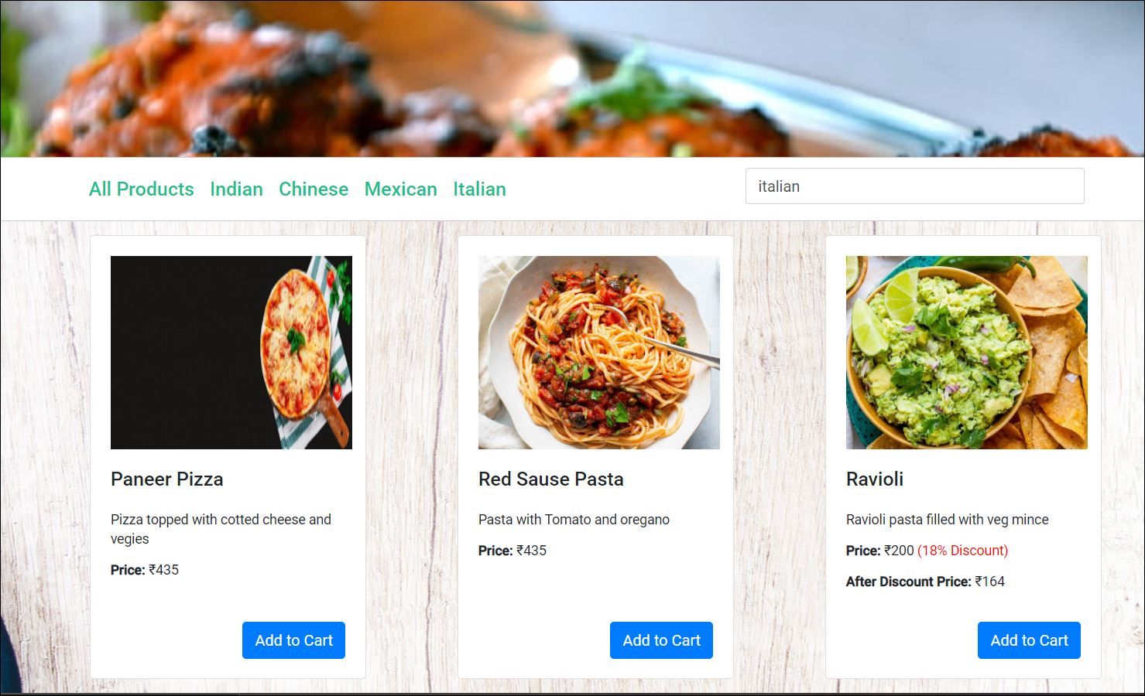

1. Previous OrderList

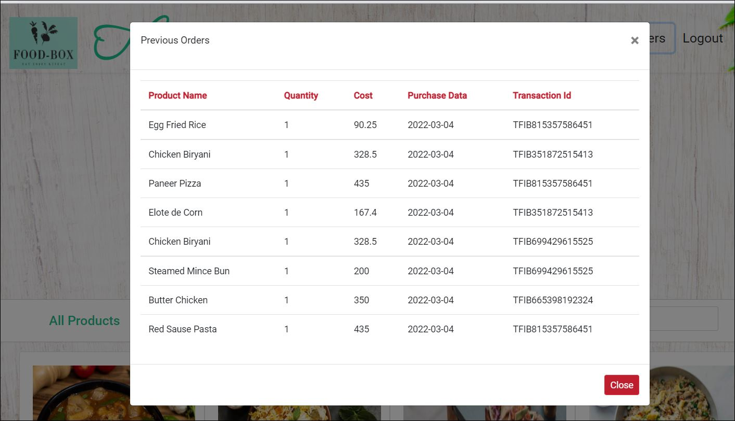

1. Cart



1. Checkout

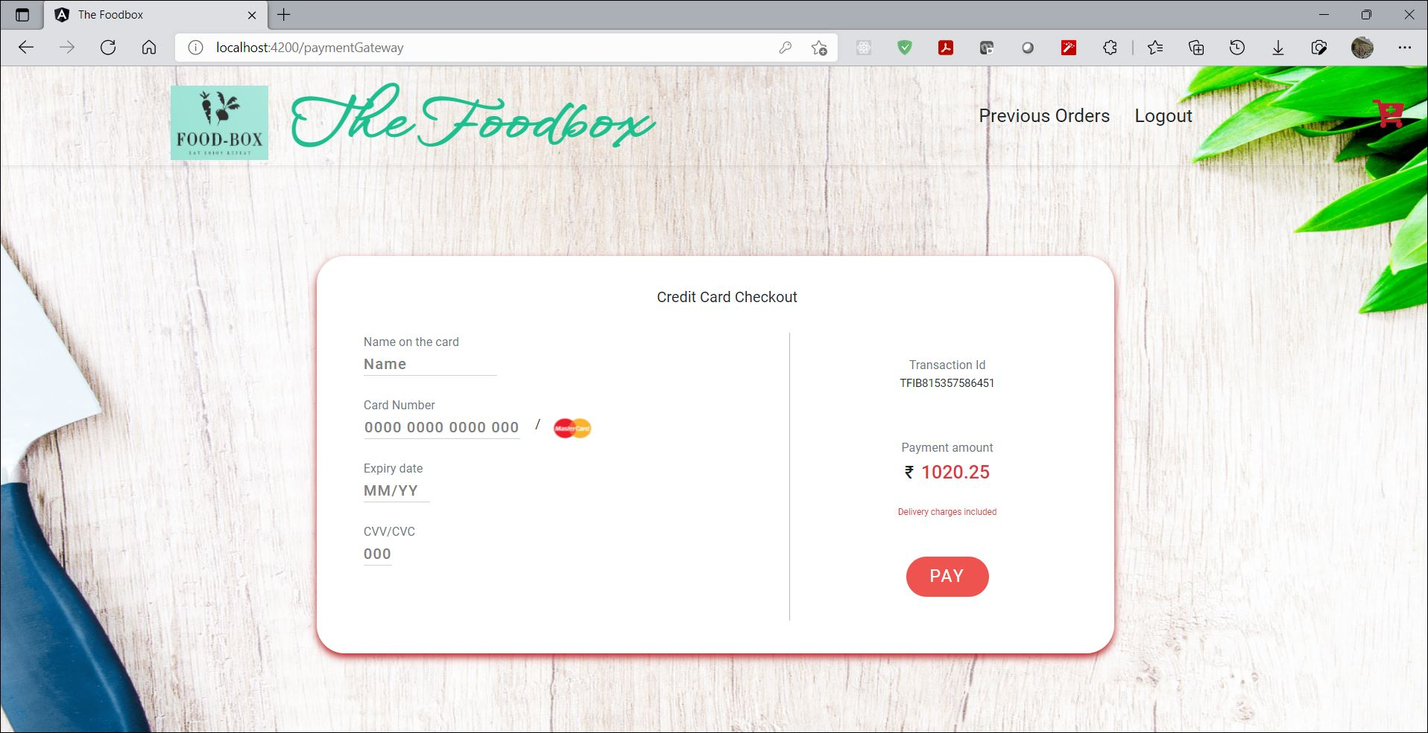

1. Confirmation Page

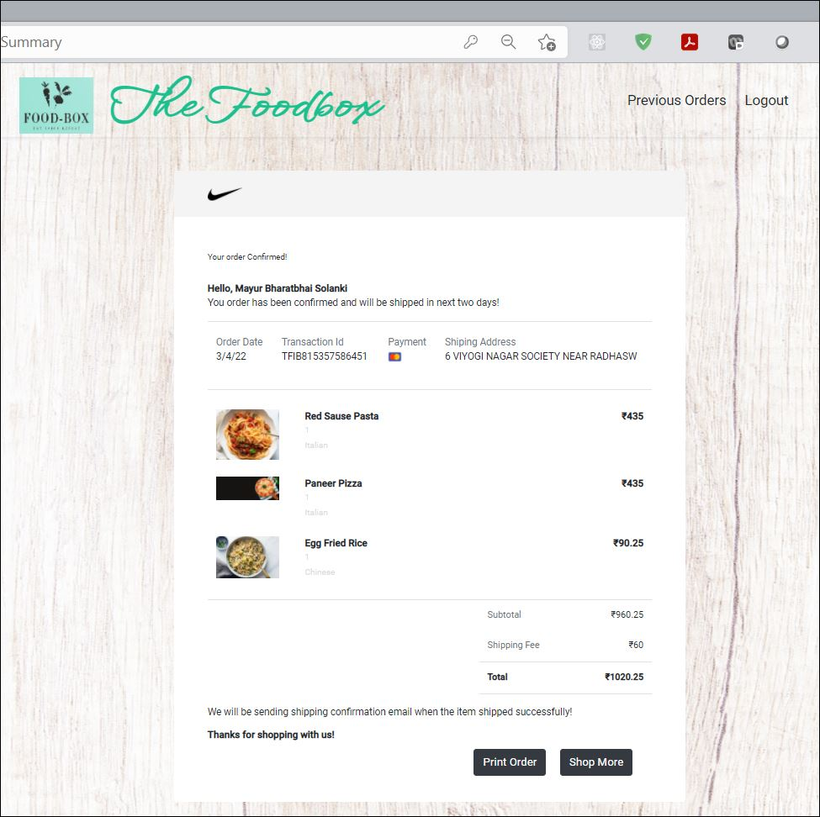

1. Database

